C Function
In c, we can divide a large program into the basic building blocks known as function. The function contains the set of programming statements enclosed by {}. A function can be called multiple times to provide reusability and modularity to the C program. In other words, we can say that the collection of functions creates a program.
MONOLITHIC VS MODULAR PROGRAMMING:
1. Monolithic Programming indicates the program which contains a single function for the large program.
2. Modular programming help the programmer to divide the whole program into different modules and each module is separately developed and tested. Then the linker will link all these modules to form the complete program.
3. On the other hand monolithic programming will not divide the program and it is a single thread of execution. When the program size increases it leads inconvenience and difficult to maintain.
A function is a group of statements that together perform a task. Every C program has at least one function, which is main(), and all the most trivial programs can define additional functions.
Advantage of functions in C:
There are the following advantages of C functions.
- By using functions, we can avoid rewriting same logic/code again and again in a program.
- We can call C functions any number of times in a program and from any place in a program.
- We can track a large C program easily when it is divided into multiple functions.
- Reusability is the main achievement of C functions.
- However, Function calling is always a overhead in a C program.

Function Aspects
There are three aspects of a C function.
- Function declaration A function must be declared globally in a c program to tell the compiler about the function name, function parameters, and return type.

- Function call Function can be called from anywhere in the program. The parameter list must not differ in function calling and function declaration. We must pass the same number of functions as it is declared in the function declaration.

- Function definition It contains the actual statements which are to be executed. It is the most important aspect to which the control comes when the function is called. Here, we must notice that only one value can be returned from the function.

Function Declaration OR Function Prototype:
1. It is also known as function prototype .
2. It inform the computer about the three things
a) Name of the function
b) Number and type of arguments received by the function.
c) Type of value return by the function
Syntax :
return_type function_name (type1 arg1 , type2 arg2);
OR
return_type function_name (type1 type2);

3. Calling function need information about called function .If called function is place before calling function then the declaration is not needed.

Function Definition:
1. It consists of code description and code of a function .
It consists of two parts
a) Function header
b) Function coding
Function definition tells what are the I/O function and what is going to do.
Syntax:
return_type function_name (type1 arg1 , type2 arg2)
{
local variable;
statements ;
return (expression);
}

2. Function definition can be placed any where in the program but generally placed after the main function .
3. Local variable declared inside the function is local to that function. It cannot be used anywhere in the program and its existence is only within the function.
4. Function definition cannot be nested.
5. Return type denote the type of value that function will return and return type is optional if omitted it is assumed to be integer by default.

Types of Functions:
There are two types of functions in C programming:
- Library Functions/Standard Function: are the functions which are declared in the C header files such as scanf(), printf(), gets(), puts(), ceil(), floor() etc.
The C standard library is a standardized collection of header files and library routines used to implement common operations, such as input/output and character string handling. Unlike other languages (such as COBOL, FORTRAN, and PL/I) C does not include built in keywords for these tasks, so nearly all C programs rely on the standard library to function.
- User-defined functions: are the functions which are created by the C programmer, so that he/she can use it many times. It reduces the complexity of a big program and optimizes the code.
A function that is declare, calling and define by the user is called user define function. Every user define function has three parts as:
1. Prototype or Declaration
2. Calling
3. Definition
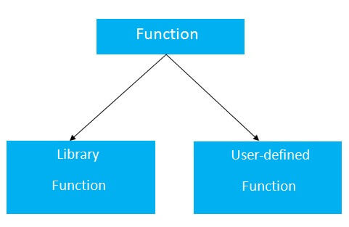
Return Value:

A C function may or may not return a value from the function. If you don't have to return any value from the function, use void for the return type.
Let's see a simple example of C function that doesn't return any value from the function.
Example without return value:

void hello()
{
printf("hello c");
}

If you want to return any value from the function, you need to use any data type such as int, long, char, etc. The return type depends on the value to be returned from the function.
Let's see a simple example of C function that returns int value from the function.

Example with return value:
int get()
{
return 10;
}
In the above example, we have to return 10 as a value, so the return type is int. If you want to return floating-point value (e.g., 10.2, 3.1, 54.5, etc), you need to use float as the return type of the method.

float get()
{
return 10.2;
}

Now, you need to call the function, to get the value of the function.

